Einstein Platform CAN E2E User Guide

Version 1.0

ISSUE DATE: Nov 4, 2025

Prepared by: abasavar
______________________________



Visteon Automotive Systems
DI Core Software Group

PROPRIETARY AND CONFIDENTIAL

This document contains information that is proprietary to Visteon Corporation. Recipients of the document shall not duplicate, use or disclose information contained herein, in whole or in part, for other than company purposes.

Contents
1. Introduction 1
2. High-Level Technical Overview 1
Key Features: 1
3. Architecture Overview 1
4. Functional Description 1
4.1 RX Path 1
4.2 TX Path 1
5. Supported E2E Profiles and Selection Guidance. 1
6. DBC Workflow and Ownership 1
BSW-COM Team Responsibilities 1
RTE Team Responsibilities 1
7. Configuration Model 1
7. 1 E2EXf Config 1
8. Application APIs & Patterns: 1

9.Tool Information

10. Flow Diagrams

11. Contact Information

1. Introduction
This guide explains how CAN End-to-End (E2E) communication protection is implemented and used in the Platform E4.0 baseline. It is written for application owners, platform integrators, and project teams who need to configure, integrate, and test E2E on CAN (and CAN-FD) I-PDUs. It covers platform architecture touchpoints, configuration workflow, project tailoring, integration guidelines, diagnostics, and verification.
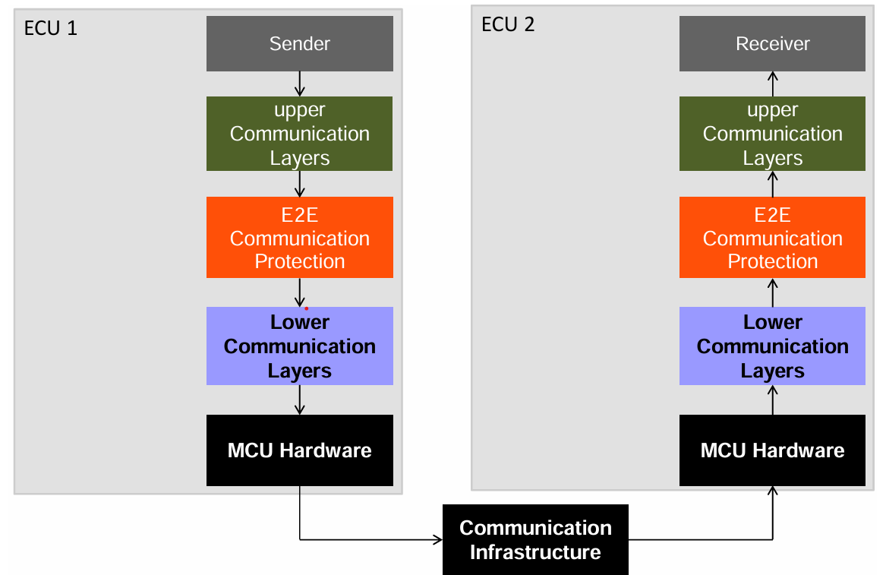

2. High-Level Technical Overview
The platform implements E2E protection for CAN safe signals using AUTOSAR-compliant E2E profiles. These profiles ensure data integrity and detect communication errors between sender and receiver components.
E2E Profiles: Platform solution uses AUTOSAR E2E Profile 01 (P01) with CRC8 (SAE J1850) and a 4‑bit counter. Other profiles may be added on CAN‑FD when payload length mandates it.
Preferred Flow: RTE E2E Transformer handles CRC/counter automatically in RX and TX paths.
Alternative Flow: E2E Protection Wrapper (E2EPW) in application code (only when transformer is unavailable). Logic and configs remain the same but calls to E2E_P01Check/Protect are made directly by the application or a wrapper.

Key Features:
- Support for AUTOSAR E2E Profiles
- Integration with RTE-generated signal interfaces
- CRC and counter-based error detection
- Configurable signal protection
- Error notification and signal data to application layers

3. Architecture Overview
CAN E2E protection is implemented at the interface between the COM stack and the application layer via the RTE. The architecture ensures that:
- Transmit signals are encoded with CRC and counter
- Receive signals are validated before being passed to the application
Modules and Roles
- ComAbsMdlSafe: Application-facing façade exposing Get/Set APIs and orchestrating buffer/retention and status mapping.
- RTE: Provides Read/Write interfaces and runs the E2E Transformer (when enabled).
- E2EXf (E2E): Performs E2E_P01Check (RX) and E2E_P01Protect (TX) on PDUs.
- ComXf: Packs/unpacks signals per ComXf_SignalConfigType mapping.
- COM/PduR/CanIf/CanDrv: Standard BSW communication path.

Tx path: Application → ComAbsMdlSafe → RTE (E2E Transformer) → COM → PduR → CanIf → CanDrv

Rx path: CanDrv → CanIf → PduR → COM → RTE (E2E Transformer) →ComAbsMdlSafe →Application

4. Functional Description

4.1 RX Path
- Frame Arrival at COM.
- E2E Check (E2E_P01Check) validates CRC and Alive counter.
- Status Update: Per-signal status bits are set (e.g., NEVER_RECEIVED, MISSING/NONEWDATA, REPEATED/WRONGSEQUENCE, INVALID_CRC, INVALID_ALIVE_COUNTER). On first valid frame, NEVER_RECEIVED is cleared.
- Unpack & Store: On OK, signals are unpacked to local mirrors and (if enabled) retention buffers (last-known-good). On NOT_OK, retention is not overwritten.
- Application Read: CComAbsMdlSafe_RxCan_GetSignalValue() returns either fresh value (if valid) or retained value (if configured), plus a consolidated status mask.

4.2 TX Path
- Application Set: CComAbsMdlSafe_TxCan_SetSignalValue() writes a value; optional TX keep-alive retention stores last value.
- Pack: ComXf packs application signals into the PDU.
- Protect: E2E_P01Protect updates counter and writes CRC at configured offsets.
- Transmit: COM/PduR/CanIf sends the frame; on confirmation, TX status/telemetry may be updated for diagnostics.
Key Rules
- App code must not write Alive/CRC fields; those are owned by E2E.
- E2E check/protect runs before the value is exposed to the app (RX) and before transmitting (TX).

5. Supported E2E Profiles and Selection Guidance.

• Profile 1 (P01, CRC8/SAE J1850, counter 4-bit): up to ~30 bytes payload; low overhead; common for classic CAN safety signals.
• Profile 2 (P02, CRC8 H2F, counter 4-bit): up to 256 bytes; higher masquerade protection; often used on CAN-FD.
• Profile 4/5/6 (CRC32/CRC16 variants): larger payloads; select when data length requires it or OEM mandates.

Note: Currently profile 1 is used as a platform solution.

6. DBC Workflow and Ownership
As part of the new DBC workflow, RTE and BSW-COM teams have distinct responsibilities. This section explains the steps and ownership, so application teams understand the upstream process and dependencies.

BSW-COM Team Responsibilities
- Import Generic ComAbsSafe.sbsx
Add the generic safety configuration file (ComAbsSafe.sbsx) into the HLD base project.
- Run Rhapsody Checker
Validate the imported configuration for consistency and correctness.
- Update ComMatrix.arxml
Insert the correct ECU Instance Name in ComMatrix.arxml after successful build validation.
- Integrate and Generate System ARXML
Merge ComMatrix.arxml and ComAbs.sbsx into the HLD base.
Execute buildinstance.bat to generate System.arxml.
- Share System ARXML with RTE Team
Provide the generated System.arxml to the RTE team (only required for the first integration cycle).

RTE Team Responsibilities
- Enable E2E Transformer in RTE configuration:
Add DataTransformationIRef and TransformerClass references for protected PDUs.
Configure E2E profile objects (e.g., E2E_P01Config).
- Signal Grouping Append the CRC and Alive signals into the safety Messages:
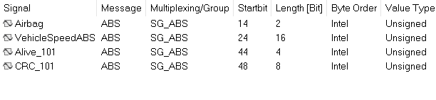
- Generate RTE code with E2E transformer enabled.
- Ensure Rte_TransformerError and E2E status are exposed to application ports.

7. Configuration Model
The platform supports three possible flows for End-to-End (E2E) protection, depending on the stack and tooling:

- RTE E2E Transformer (Preferred Approach)
- E2E Protection Wrapper (E2EPW) in Application Code
- COM Callout (BSW – LAYER)
1. RTE E2E Transformer Configuration [Used as a platform solution]
This configuration involves setting up the E2E transformer within the RTE layer. It includes the following components:

7. 1 E2EXf Config
- E2E Profile Configuration (e.g., E2E_P01ConfigType):
DataLength – Length of the protected data.
CRCOffset – Position of CRC within the message.
CounterOffset – Position of sequence counter.
DataID – Unique identifier for the data.
DataIDMode – Mode for DataID usage.
DataIDNibbleOffset – Offset for DataID nibble.
- E2E State Machine Configuration:
MaxDeltaCounterInit – Maximum allowed delta for counter initialization.
MaxNoNewOrRepeatedData – Threshold for repeated or missing data.
SyncCounterInit – Initial synchronization counter.
Note: E2E profile configuration must be tailored based on the message details.
Example 1: ABS RX — E2E Transformer Path
{E2E_P01_DATAID_BOTH, 44u, 48u, 0x0102u, 0u, 56u, 15u, 2u, 1u } /* ABS_CONTROL */
- The transformer reads the ABS PDU (7 bytes), checks E2E Profile 01 with:
CounterOffset = 44, CRCOffset = 48, DataLength = 56, DataID = 0x0102, DataIDMode = BOTH.
- E2E_P01Check updates the per-message state (E2E_P01CheckStateType) and sets one of:
OK, NONEWDATA, WRONGCRC, SYNC, INITIAL, REPEATED, OKSOMELOST, WRONGSEQUENCE.
- The wrapper returns E_OK for {OK, OKSOMELOST, SYNC} and E_NOT_OK otherwise, and sets *bufferLength to the consumed byte length.
- The application may additionally inspect E2EstateRx_status[ABS].Status to decide warning/fallback behavior.
Concurrency & Reentrancy
- Keep one E2E_P01CheckStateType per PDU/instance.
- The function is reentrant per message if states are partitioned per index.


Example 2: Cluster_Tx_Normal_COM_HS — E2E Transformer Path[TX]
const E2E_P01ConfigType E2EdataTx_config[NUM_CAN_MSG_TX] =
{
{E2E_P01_DATAID_BOTH, 8u, 16u, 0x200, 0u, 24, 0u, 0u, 1u} /* 0Cluster_Tx_Normal_COM_HS */
};

When E2E_P01Protect (cfg, &state, pdu) is called:
- Counter update
Reads the 4-bit counter at CounterOffset (8..11), increments (mod 16), writes back.
- CRC calculation
Computes CRC8 over the protected area according to P01 (includes DataID per DataIDMode) and writes the CRC byte at CRCOffset (16...23).
- Return status
Typically, E2E_P01STATUS_OK if protection succeeded. TX uses this mainly for diagnostics/logging.
Note: The receiver must use the same DataID, DataIDMode, CounterOffset, CRCOffset, and DataLength, or checks will fail.

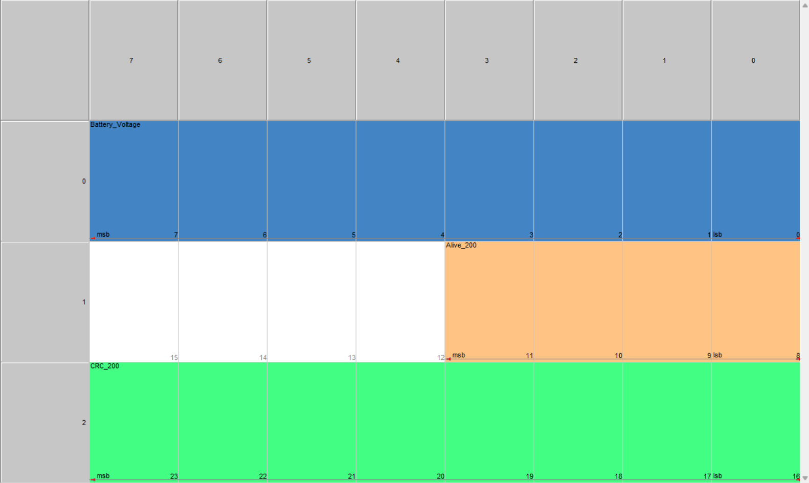

7.2 ComXf Configuration:
ComXf_SignalConfigType describes how each signal is packed into (TX) or unpacked from (RX) an I‑PDU at the bit level: data type, endianness, bit range, and byte boundaries. It must be consistent with the E2E configuration (counter/CRC offsets and total PDU length).
TX path (RTE → COM/CanIf):
- Application produces signal values.
- ComXf pack signals into the PDU using ComXf_SignalConfig.
- E2E_P01Protect updates counter and CRC at their offsets.
- COM/CanIf sends the frame.

RX path (CanIf/COM → RTE):
- Frame arrives.
- E2E_P01Check validates counter/CRC and updates status.
- ComXf unpack extracts application signals using ComXf_SignalConfig.
- Application consumes data and status.
Note: Do not let ComXf (or the app) overwrite the counter/CRC. Those fields are written/read exclusively by the E2E module.
Example 1: ABS_CONTROL (RX) — extract application signals
E2E (recap): DataLength=56, CounterOffset=44, CRCOffset=48, DataID=0x0102.

From layout:
- VehicleSpeedABS: bits 24..43 (20 bits)
- Counter nibble: 44..47 (internal)
- CRC byte: 48..55 (internal)
Example 2: : Cluster_Tx_Normal_COM_HS [TX] — pack application signal and leave E2E fields to the profile
E2E (recap): DataLength=24, CounterOffset=8, CRCOffset=16, DataID=0x0200.
From layout:
- Battery_Voltage: bits 0..7
- Alive_200: 8..11 (internal, E2E increments)
- CRC_200: 16..23 (internal, E2E writes)

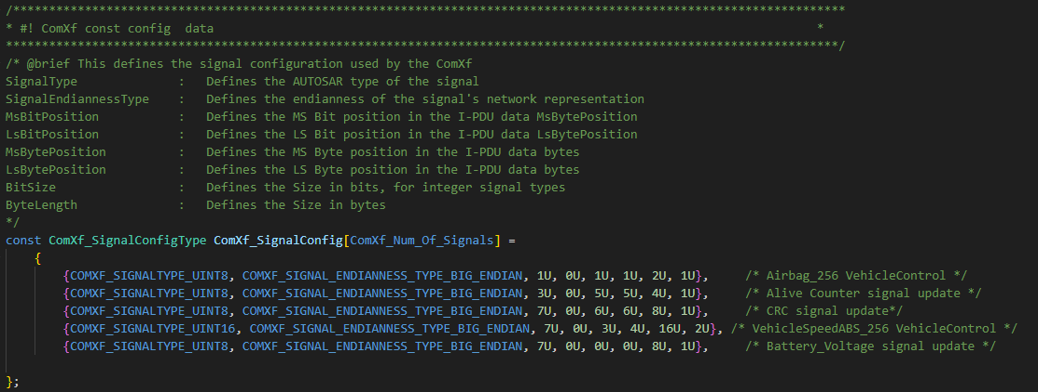

7.3 ComAbsMdlSafe Configuration
The ComAbsMdlSafe configuration layer is responsible for invoking the RTE API, processing its return values, handling transformation errors, and passing the processed information to the application layer.
7.3.1 Purpose
- To read message data from RTE.
- To interpret transformation errors and E2E status.
- To provide a standardized interface for the application to consume validated and transformed data.
7.3.2 RTE Return Values
- When invoking the RTE API for a monitored message, the following elements are returned:
7.3.3 Message Data
- Example: SG_ABS Msg
- The type of message depends on the signal or message being monitored.

7.3.4 Transformer Error Information
- Structure:
typedef struct {
Rte_TransformerErrorCode errorCode;
Rte_TransformerClass transformerClass;
} Rte_TransformerError;
This provides details about any transformation issues encountered during data processing.
7.3.5 E2E Status Codes
The errorCode can map to E2E status values, which indicate the integrity and freshness of the received data:
- E2E_P01STATUS_OK – Data is valid.
- E2E_P01STATUS_NONEWDATA – No new data received.
- E2E_P01STATUS_WRONGCRC – CRC check failed.
- E2E_P01STATUS_SYNC – Synchronization in progress.
- E2E_P01STATUS_INITIAL – Initial state.
- E2E_P01STATUS_REPEATED – Repeated data detected.
- E2E_P01STATUS_OKSOMELOST – Data valid but some frames lost.
- E2E_P01STATUS_WRONGSEQUENCE – Sequence error detected.
7.3.6 RTE API Return Codes
The RTE API itself can return one of the following:
- RTE_E_OK – Successful read and transformation.
- RTE_E_NEVER_RECEIVED – No data ever received.
- RTE_E_SOFT_TRANSFORMER_ERROR – Non-critical transformation error.
- RTE_E_HARD_TRANSFORMER_ERROR – Critical transformation error.
- Processing Logic
Based on these return values:
- Validate message integrity using E2E status.
- Handle transformation errors according to severity.
- Forward processed data and status to the application for further use.

ret | errorcode | signalstatus | Signalvalue
RTE_E_HARD_TRANSFORMER_ERROR | NA | eSIGNAL_INVALID | NA
RTE_E_SOFT_TRANSFORMER_ERROR | E2E_P01STATUS_WRONGCRC | eSIGNAL_INVALID_CRC | NA
RTE_E_SOFT_TRANSFORMER_ERROR | E2E_P01STATUS_WRONGSEQUENCE | eSIGNAL_INVALID_ALIVE  _COUNTER | NA
RTE_E_SOFT_TRANSFORMER_ERROR | E2E_P01STATUS_REPEATED | eSIGNAL_REPEATED | NA
RTE_E_SOFT_TRANSFORMER_ERROR | E2E_P01STATUS_SYNC | eSIGNAL_OK | Signal Value
RTE_E_SOFT_TRANSFORMER_ERROR | E2E_P01STATUS_INITIAL | eSIGNAL_OK | Signal Value
RTE_E_OK | NA | eSIGNAL_OK | Signal Value
RTE_E_NEVER_RECEIVED | NA | eSIGNAL_NEVER_RECEIVED | NA

8. Application APIs & Patterns:
8.1 CComAbsMdlSafe_RxCan_GetSignalValue ():
Prototype:
Std_ReturnType CComAbsMdlSafe_RxCan_GetSignalValue
( tRxSafeSignalId SignalId,
uint8 *pSignalValue,
tRxSafeSignalStatus *pSignalStatus
);
Purpose:
Fetches the current value of a configured RX “safe” signal and returns its derived from the E2E check and runtime monitoring.
The API decides whether to read fresh COM buffer content or a locally retained value (retention buffer) based on signal status and configuration.

Parameters:
- SignalId (tRxSafeSignalId, in)
Logical ID of the safe RX signal. Must be < eEndOfSafeRxSignal.
- pSignalValue (uint8*, out)
Pointer to application buffer where the value is written.
Width depends on configuration (SignalLengthInByte):
1 byte → the API writes uint8 to *pSignalValue
2 bytes → the API writes uint16 to *(uint16*)pSignalValue
3–4 bytes → the API writes uint32 to *(uint32*)pSignalValue
- pSignalStatus (tRxSafeSignalStatus*, out)
Bit-mask status describing the quality of the returned value (see Signal Status).
Return:
- E_OK – API executed; *pSignalValue and *pSignalStatus are valid.
- E_NOT_OK – Parameter error or buffer index/length invalid for the configured signal (no write to output guaranteed).
Signal Status (tRxSafeSignalStatus)
*pSignalStatus is a bit field. Typical flags:
- eSIGNAL_OK – No issues detected.
- eSIGNAL_INVALID – Value flagged by InvalidCheck hook (range, plausibility, etc.).
- eSIGNAL_NEVER_RECEIVED – No frame ever received for this signal since startup.
- eSIGNAL_MISSING – Missing data indicated by monitoring (timeout or E2E “no new data”).
- eSIGNAL_REPEATED – Repetition/sequence error detected.
- eSIGNAL_INVALID_CRC – E2E check reported CRC failure.
- eSIGNAL_INVALID_ALIVE_COUNTER – E2E counter/sequence failure.
Note: These flags are typically populated by the E2E layer and monitoring logic into internal bit arrays

8.2 CComAbsMdlSafe_TxCan_SetSignalValue ():
Prototype:
Std_ReturnType CComAbsMdlSafe_TxCan_SetSignalValue
( tTxSignalId SignalId,
uint8 *pTxSignalData
);
Purpose:
Sets a TX safe signal into the COM/driver path using a configured setter function.
Optionally stores the value in a TX retention (“keep‑alive”) buffer so it can be reused on periodic sends or during recoveries (as per signal properties).
Parameters:
- SignalId (tTxSignalSafeId, in)
Index into ComAbsMdlSafe_TxCanSignalConfig; must be < eEndOfTxSignal.
- pTxSignalData (uint8*, in)
Pointer to the value to transmit. The function reads 1, 2, or up to 4 bytes based on the signal’s SignalLengthInByte.
Return:
- E_OK – Value accepted and forwarded to the configured setter.
- E_NOT_OK – Invalid arguments or configuration (e.g., null pointer, out-of-range length/index, no setter).

9. Tool Information
The ComAbsMdlSafe code generation tool is a command-line application that automates the creation of C source and header files for the ComAbsMdlSafe component. This component is responsible for the abstraction and safe handling of CAN (Controller Area Network) signals between Software Components (SWCs) and the underlying AUTOSAR Basic Software (BSW) communication stack.
The tool consists of multiple Python scripts that work together to generate configuration files based on an input Excel spreadsheet. This automation ensures consistency, reduces manual errors, and streamlines the integration process for new or modified CAN signals.

9.1 Prerequisites
To use this tool, the following software must be installed on your system:
• Python 3.x: The tool is written in Python 3.
• Python Packages:
• openpyxl: For reading and writing Excel files.
• click: For creating the command-line interface.
• Input Files:
• A DBC (CAN database) file containing the CAN message and signal definitions.
• A configuration Excel file (e.g., an SRD - Software Requirements Document) that contains the project-specific signal configuration.

9.2 Tool Architecture and Scripts
The tool is composed of several Python scripts, each with a specific responsibility:
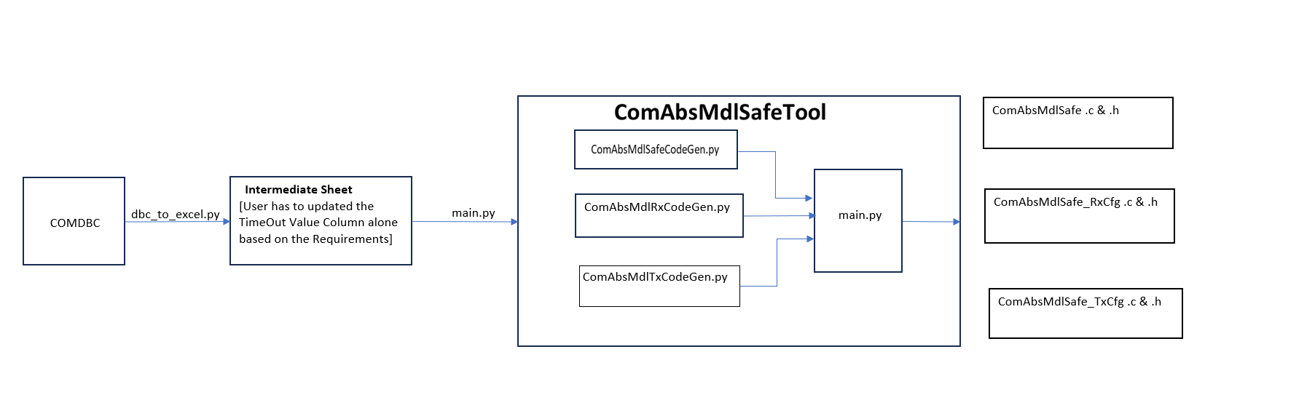
9.2.1 main.py
This is the primary entry point for the tool. It provides a command-line interface (CLI) using the click library, allowing users to execute different commands.
•genexcel command: This command generates an intermediate Excel configuration file by merging data from the input SRD Excel file and the DBC file.
•gencode command: This command generates the final C code (ComAbsMdlSafe.h, ComAbsMdlSafe.c, ComAbsMdlSafe_TxCfg.h, ComAbsMdlSafe_TxCfg.c, ComAbsMdlSafe_RxCfg.h, ComAbsMdlSafe_RxCfg.c) based on the intermediate Excel configuration file.
9.2.2 ComAbsMdlCodeGen.py
This script generates the core ComAbsMdlSafe.h and ComAbsMdlSafe.c files. These files contain the main implementation of the ComAbsMdlSafe module, including its public API, internal data structures (buffers, status flags), and lifecycle management functions.
9.2.3 ComAbsMdlRxCodeGen.py
This script generates the configuration files for receiving CAN signals: ComAbsMdlSafe_RxCfg.h and ComAbsMdlSafe_RxCfg.c. It reads the "RxSignals" sheet from the input Excel file to configure signal reception, including E2E protection, monitoring (e.g., missing, invalid), and retention.
9.2.4 ComAbsMdlTxCodeGen.py
This script generates the configuration files for transmitting CAN signals: ComAbsMdlSafe_TxCfg.h and ComAbsMdlSafe_TxCfg.c. It reads the "TxSignals" sheet from the input Excel file to configure signal transmission, including confirmation handling and value retention.

9.3 Tool Usage
The tool is executed from the command line using the .py script
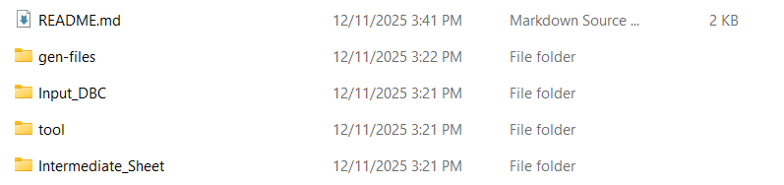
Step 1: User can place their DBC inside the Input_DBC folder
Step 2: open cmd from the path like below from the tool folder
C:\ComAbsMdlSafePythonSource\tool>
and run this command
python dbc_to_excel.py --dbc PlatformDBCE4v7.dbc --node IC
Step 3: Intermediate Sheet will get generated inside the Intermediate_Sheet folder as below format
RxSignals Sheet
Column | Description
A | Signal Name (e.g., VehicleSpeedABS)
B | VSignal Name (e.g., VSPEED_ABS)
C | VSignal Enum (e.g., eVSPEED_ABS)
D | Enabled (TRUE/FALSE)
E | Length in bits
F | Timeout Value (ms)
G | Message Name (as defined in DBC)
H | Message Callback (TRUE/FALSE)

TxSignals Sheet
COLUMN | DESCRIPTION
A | Signal Name (e.g., BatteryVoltage)
B | VSignal Name (e.g., BATT_VOLT)
C | VSignal Enum (e.g., eBATT_VOLT)
D | Enabled (TRUE/FALSE)
E | Length in bits
F | Message Name (as defined in DBC)
G | Internal Signal (TRUE/FALSE)
H | Tx Confirm (TRUE/FALSE)

Step 4: Once the intermediate sheet is generated user must update the Timeout Value(ms) [column F] in the RxSignals sheet manually based on the specifications.
Step 5: Once the updation is done use the
Below command to generate the cfg files generation
open cmd from the path like below
C:\ComAbsMdlSafePythonSource\tool>
and run this command
python main.py gencode -iexcel "Intermediate_sheet.xlsx"
Step 6: Config files are get generated inside the gen-files folder as below.
• ComAbsMdlSafe.h
• ComAbsMdlSafe.c
• ComAbsMdlSafe_TxCfg.h
• ComAbsMdlSafe_TxCfg.c
• ComAbsMdlSafe_RxCfg.h
• ComAbsMdlSafe_RxCfg.c
Step 7: Once Cfg files are generated user can integrate and check for the build.
Step 8: User must invoke ComAbsMdlSafe_RxCanGetFrom_MessageName__Core from the runnable based on the respective message periodicity.
9.6 Tool Limitations
- Toll is not ready to accept DBC as an Input directly
- User must fill Timeout Value(ms) [column F] and Signal Invalid Value [column J] in the RxSignals sheet manually which is generated by the DBC
- Not fully automated
- Tool will only support for Intel byte order [Little endian] format
- No GUI — CLI only
- Program team is responsible for to verify the generated files using different verification methods [Ex: Unit Testing, Static Analysis etc...]
- Program team is responsible to provide the proper DBC file
9.7 Future RoadMap
- Support full automation
- Automatic MISRA formatting of generated code
- Support Big Endian byte order format
10. Flow Diagrams
RX Flow:
CAN frame → RTE → E2EXf (CRC & Alive check) → ComXf unpack → ComAbsMdlSafe_Rx updates buffers → App reads via GetSignalValue().
TX Flow:
App writes via SetSignalValue() → ComAbsMdlSafe_Tx → ComXf packs → E2EXf adds CRC & Alive → RTE sends → COM/CanIf transmit.

10. Contact Information
Role | Name | CDSID
Module Owner | Abhilash Basavarajappa | ABSAVAR
Reviewer | Moses Savariyar | MSAVARIY

